1). Execute the script shown in the video.
STEP 1 — Create Project Folder
Visual Studio / Git Bash:
mkdir terraform-local-demo
Go inside folder:
cd terraform-local-demo

terraform {
required_providers {
local = {
source = "hashicorp/local"
version = "2.3.0"
}
}
}
resource "local_file" "my-pet" {
filename = "pets.txt"
content = "I love cats!"
}

Explanation of Code
terraform block
Defines:
- Required providers
- Provider version
terraform {
required_providers {

local provider
Uses HashiCorp local provider.
source = "hashicorp/local"

resource block
Creates infrastructure resource.
resource "local_file" "my-pet"
Where:
- local_file → resource type
- my-pet → resource name

filename
Creates:
pets.txt

content
Writes inside file:
I love cats!

### Commands
Bash
terraform init
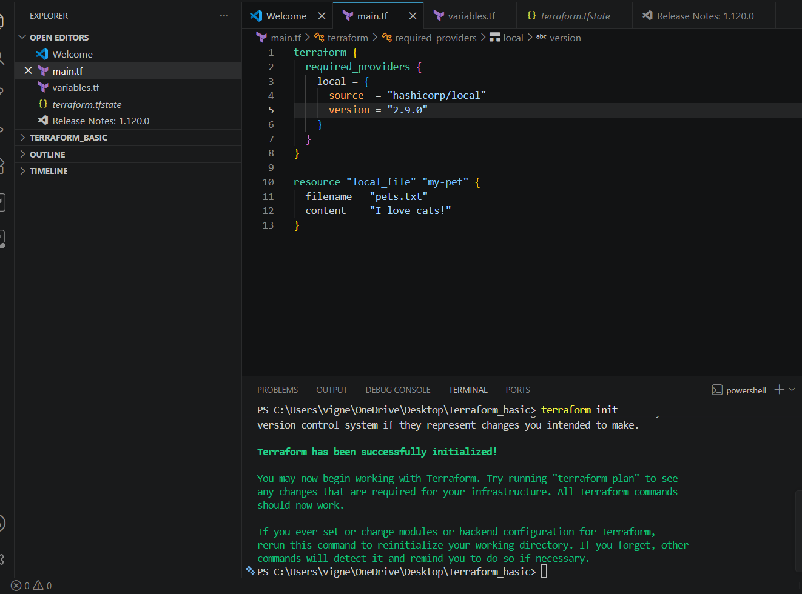
terraform plan
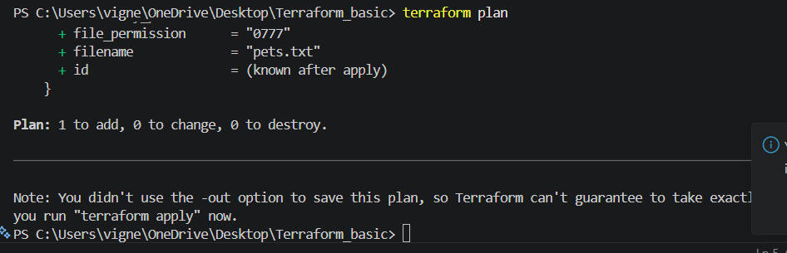

terraform apply
When Terraform asks:

bash
Enter a value:

Type:

bash
yes

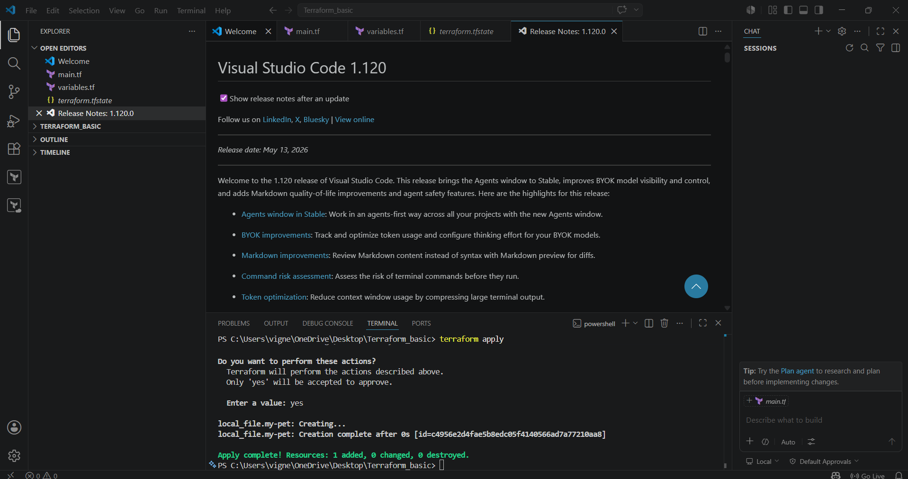

2. Terraform Variables Example
Now we will use:
- variables.tf
- List variables
- Multiple file creation using Terraform

Objective
Terraform will create:
pets.txt
cats.txt
dogs.txt
automatically.

Project Structure
terraform-variable-demo/
│
├── main.tf
├── variables.tf
└── terraform.tfvars (optional)

STEP 1 — Create Project Folder
mkdir terraform-variable-demo
Go inside:
cd terraform-variable-demo

STEP 2 — Create variables.tf
Create file:
vi variables.tf
Paste:
hcl
variable "filename" {
default = [
"pets.txt",
"cats.txt",
"dogs.txt"
]
}
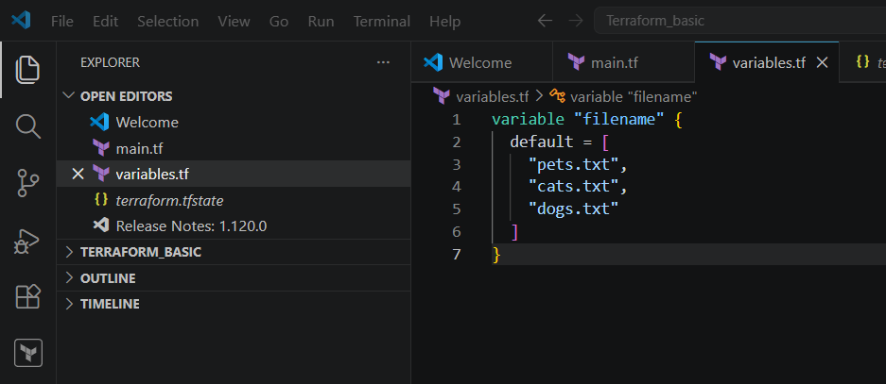
STEP 3 — Create main.tf
Create:
vi main.tf
Paste:
hcl
resource "local_file" "my-pet" {
filename = var.filename[count.index]
content = "I love cats!"
count = 3
}
Explanation
variable
Creates Terraform variable.
variable "filename"

default
Stores default values.

List Variable
This is a list:
[
"pets.txt",
"cats.txt",
"dogs.txt"
]

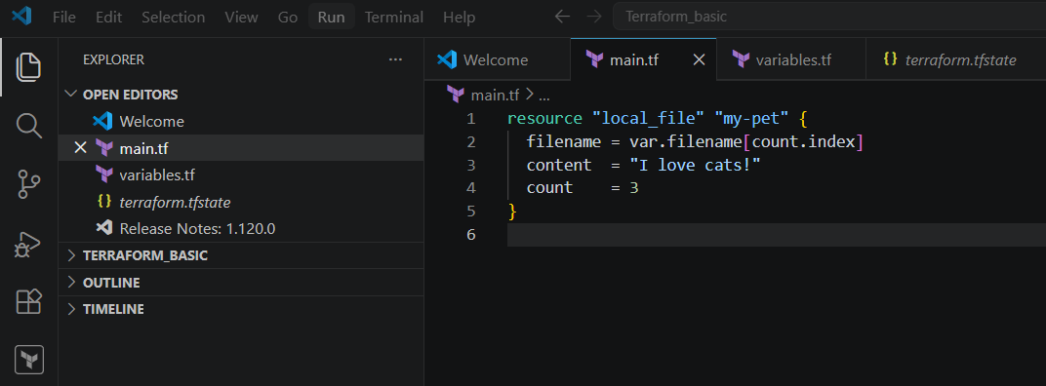
### Commands

bash
terraform init
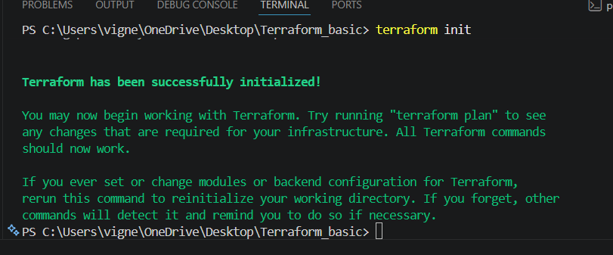

terraform plan
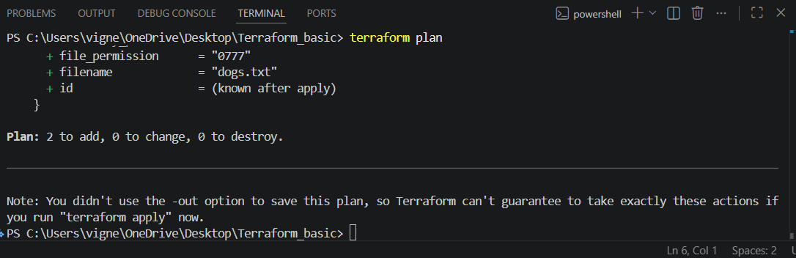

terraform apply
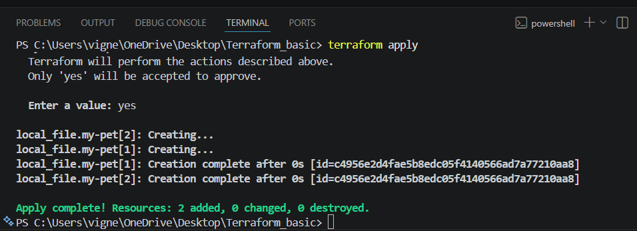
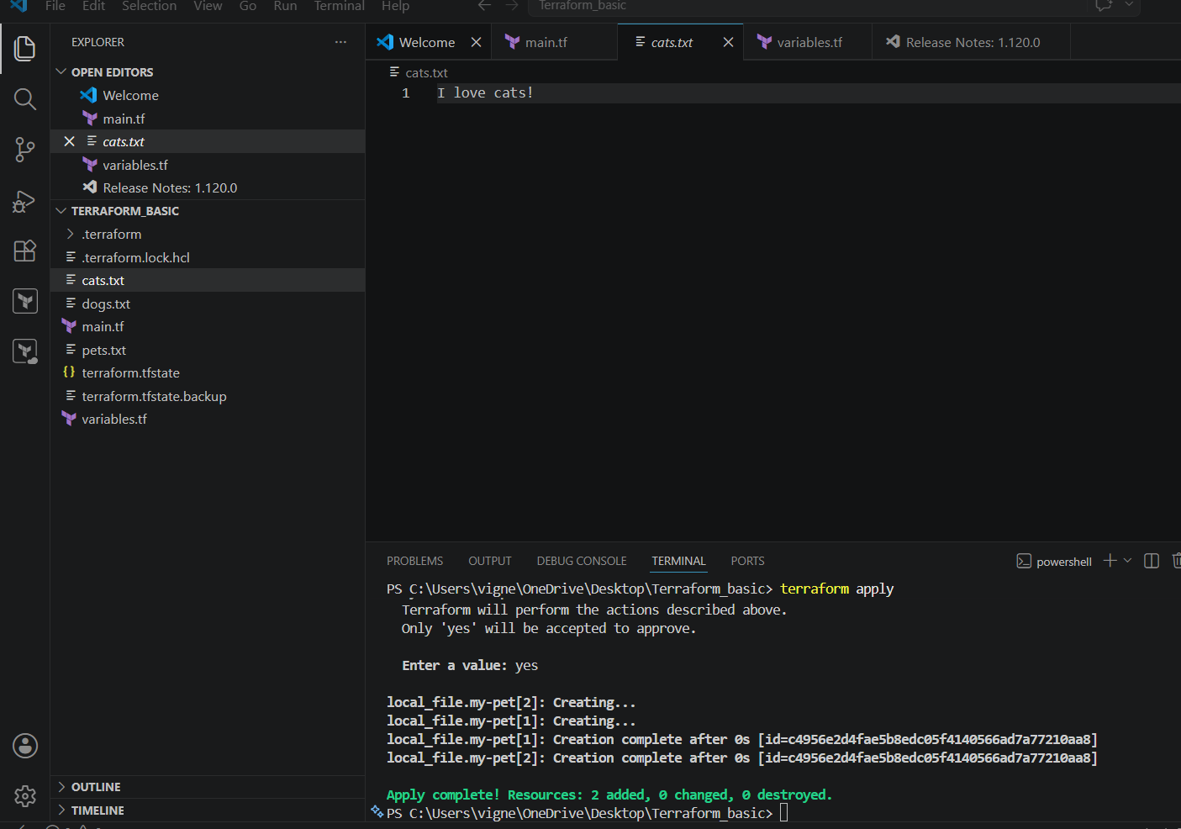

This creates:

* pets.txt
* cats.txt
* dogs.txt

3) Terraform for_each Example

### variables.tf
hcl
variable "filename" {
default = [
"pets.txt",
"cats.txt",
"dogs.txt"
]
}
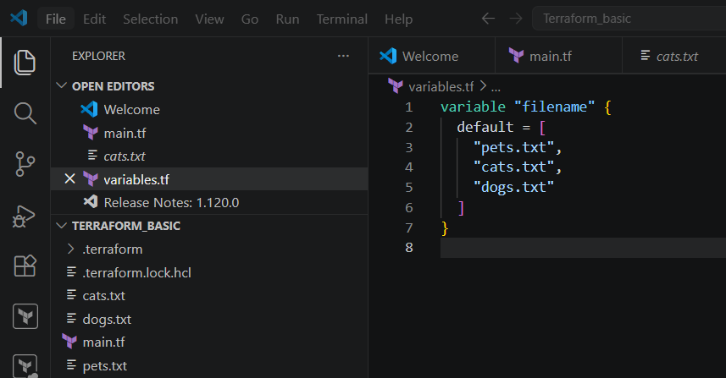

### main.tf
hcl
resource "local_file" "pet" {
filename = each.value
for_each = toset(var.filename)
content = "Terraform for_each example"
}
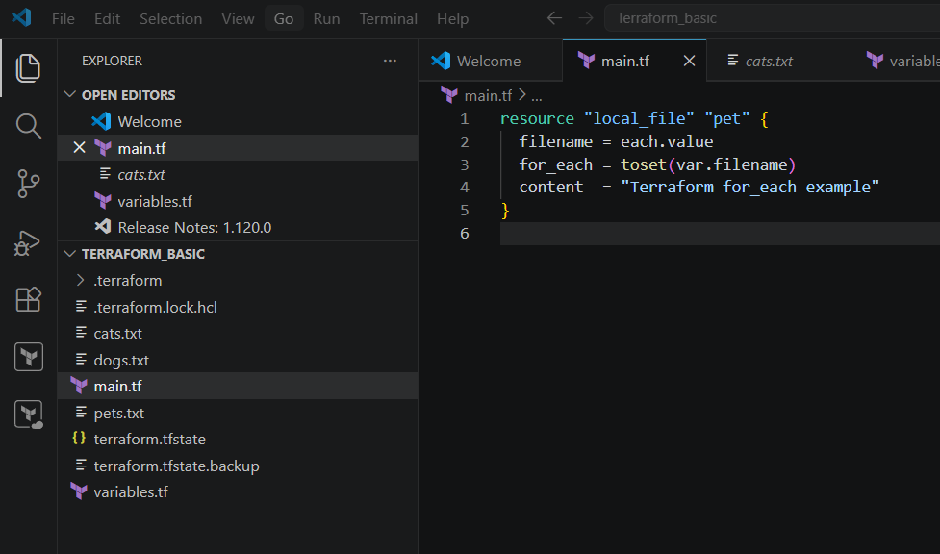

### Commands
bash
terraform init
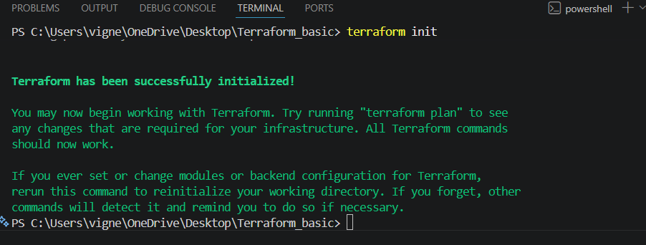

terraform plan

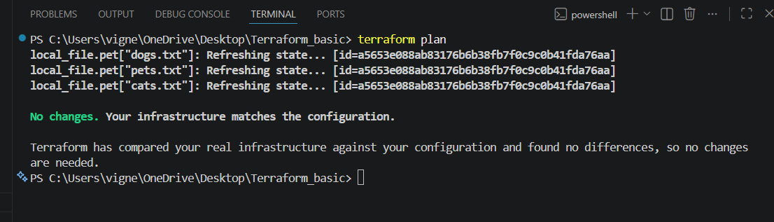
terraform apply

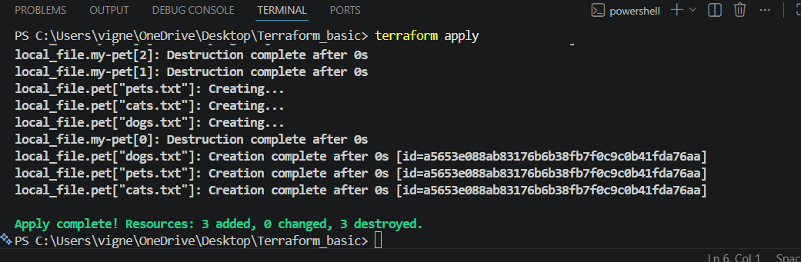

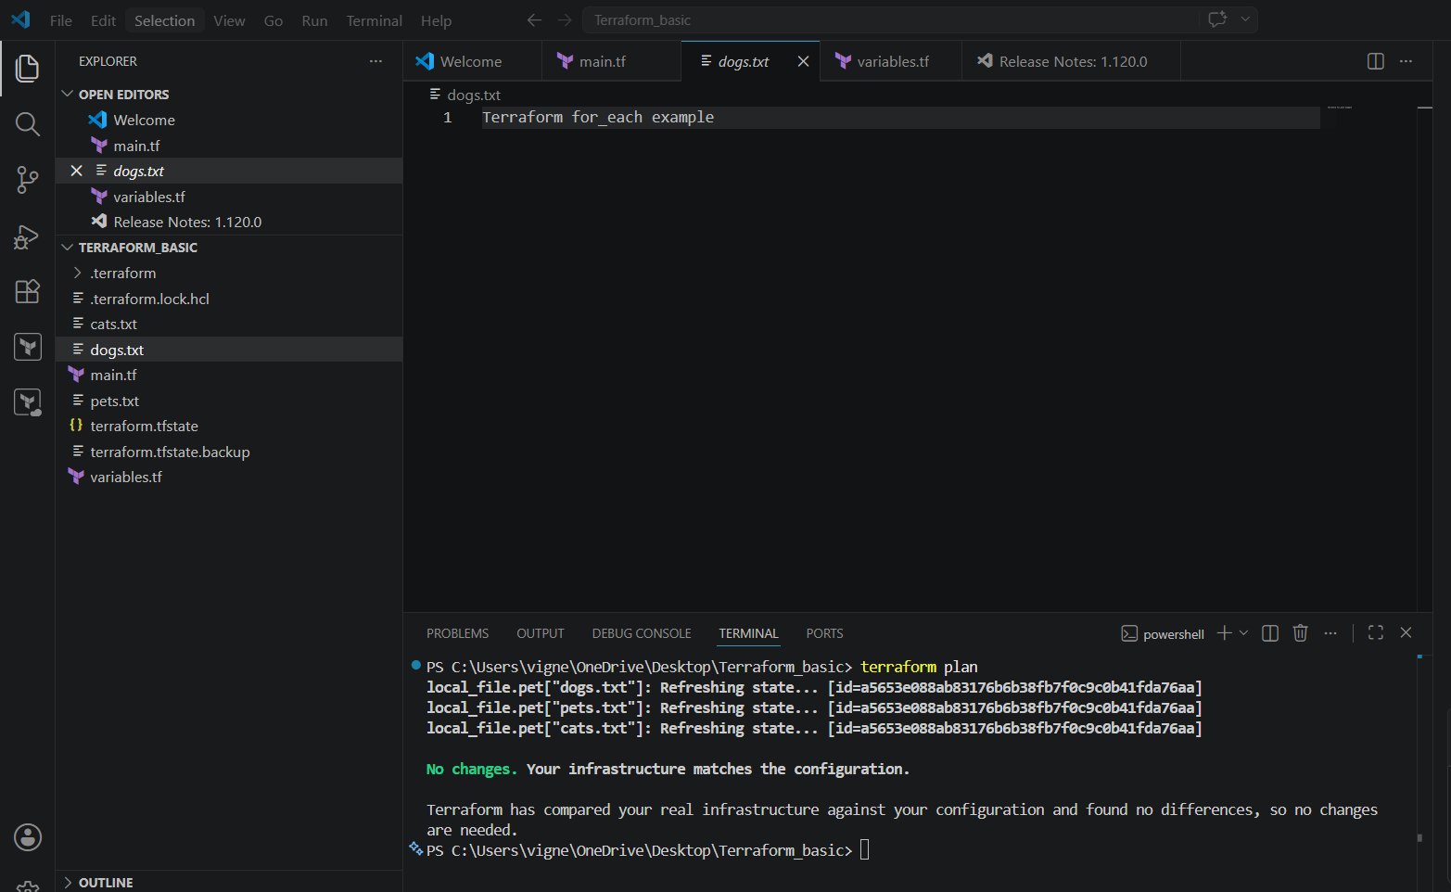

4) Terraform AWS IAM User Example
## Prerequisites
Install and configure AWS CLI:
Bash
aws configure
Provide:
* AWS Access Key
* AWS Secret Key
* Region
* Output format

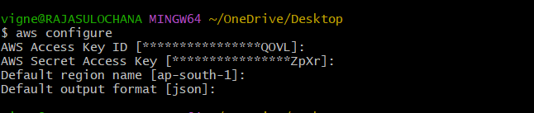

## Create IAM User

### main.tf
hcl
resource "aws_iam_user" "Admin-user" {
name = "Vignesh"
tags = {
"Description" = "IT"
}
}
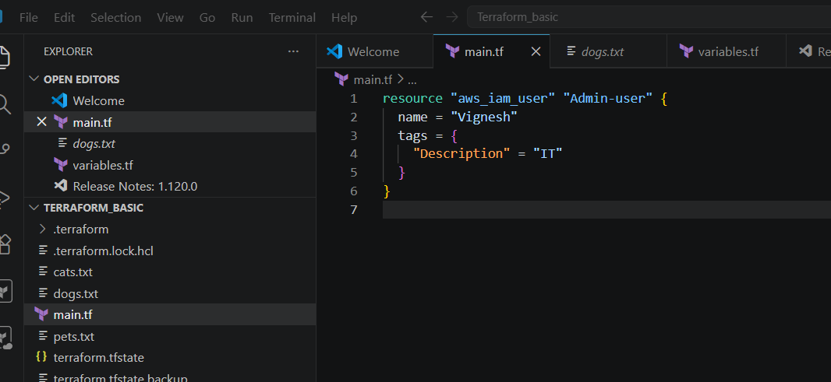

### Commands
Bash
terraform init
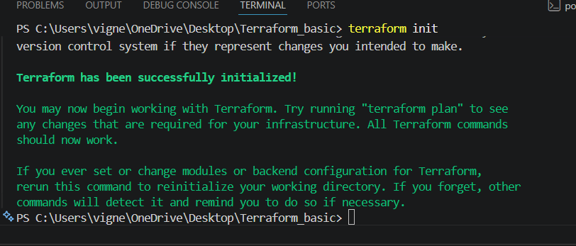
terraform plan
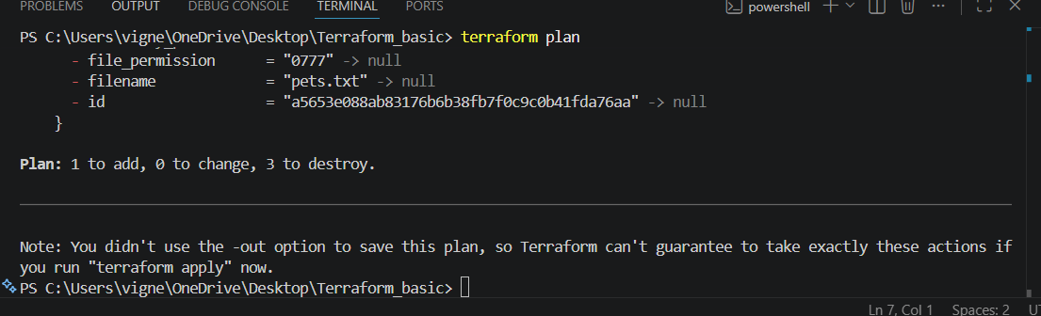
terraform apply

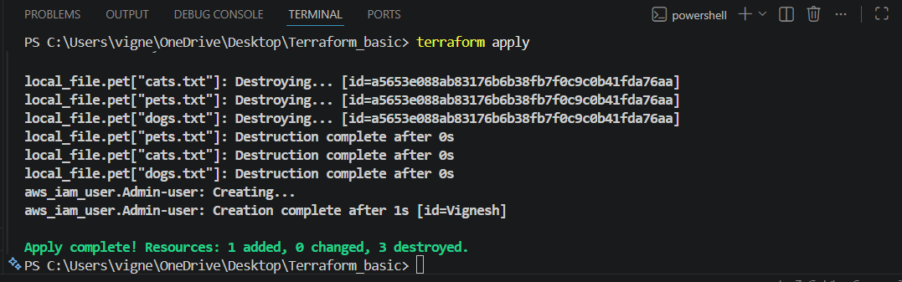

Verify In IAM User

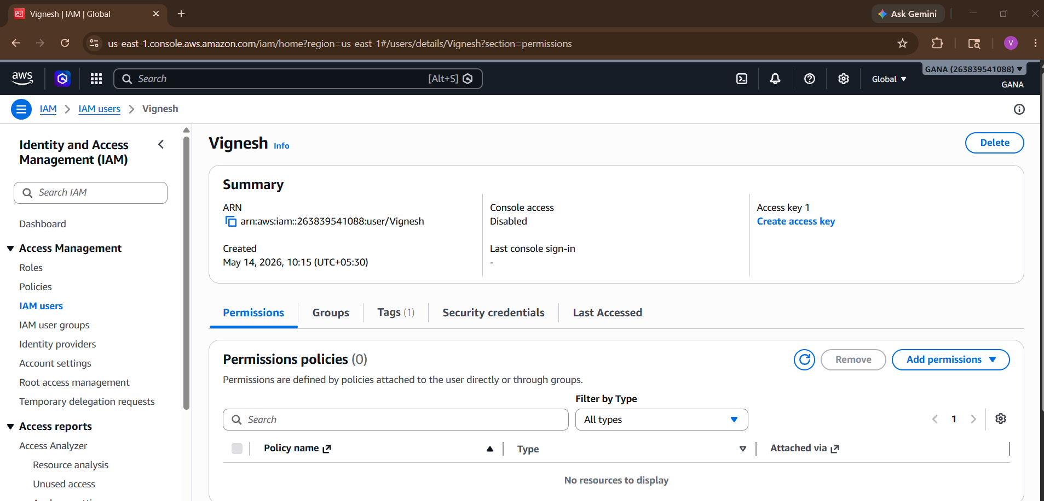

5) Create IAM Policy and Attach Policy

### main.tf

hcl
resource "aws_iam_user" "Admin-user" {
name = "lucy"
}
resource "aws_iam_policy" "adminuser" {
name = "AdminUser"
policy = <<EOF
{
"Version": "2012-10-17",
"Statement": [
{
"Effect": "Allow",
"Action": "*",
"Resource": "*"
}
]
}
EOF
}
resource "aws_iam_user_policy_attachment" "lucy-admin-access" {
user = aws_iam_user.Admin-user.name
policy_arn = aws_iam_policy.adminuser.arn
}

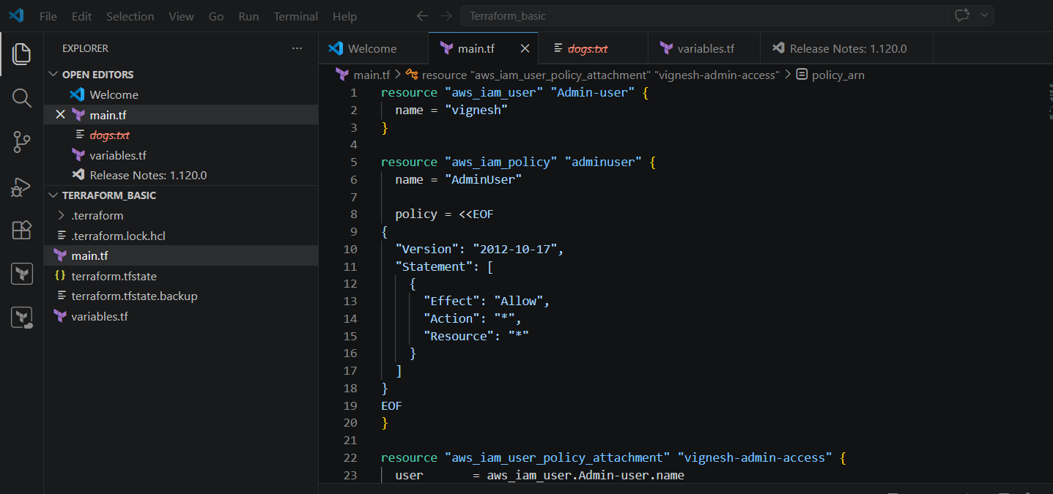

### Commands
Bash
terraform init
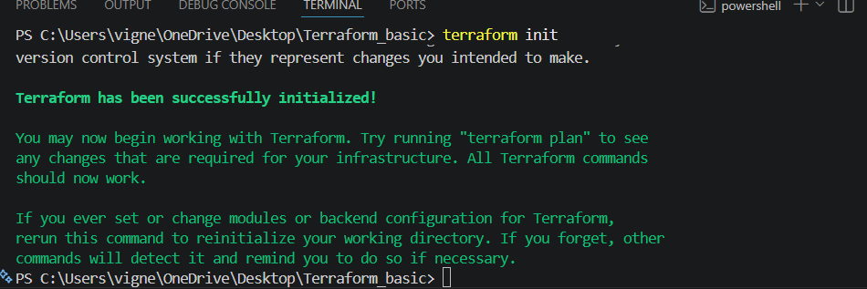
terraform plan
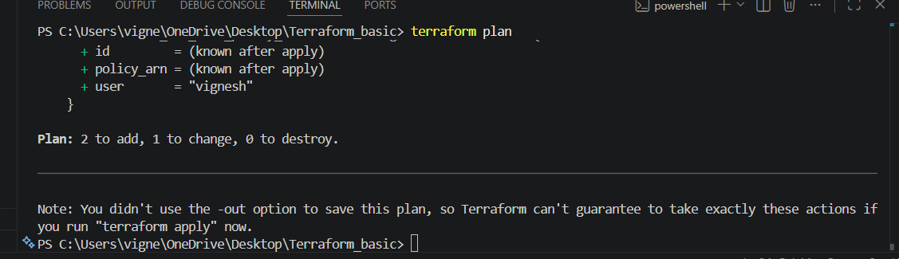
terraform apply
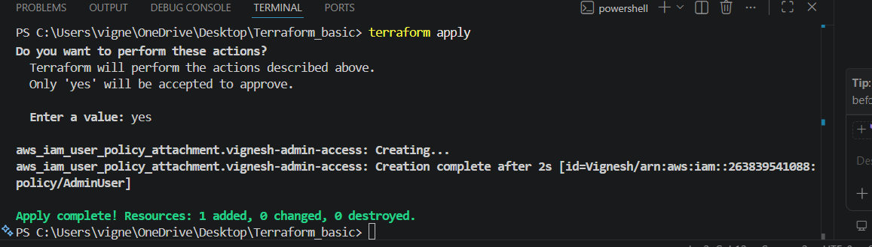
Verify IN IAM ROLE Policy
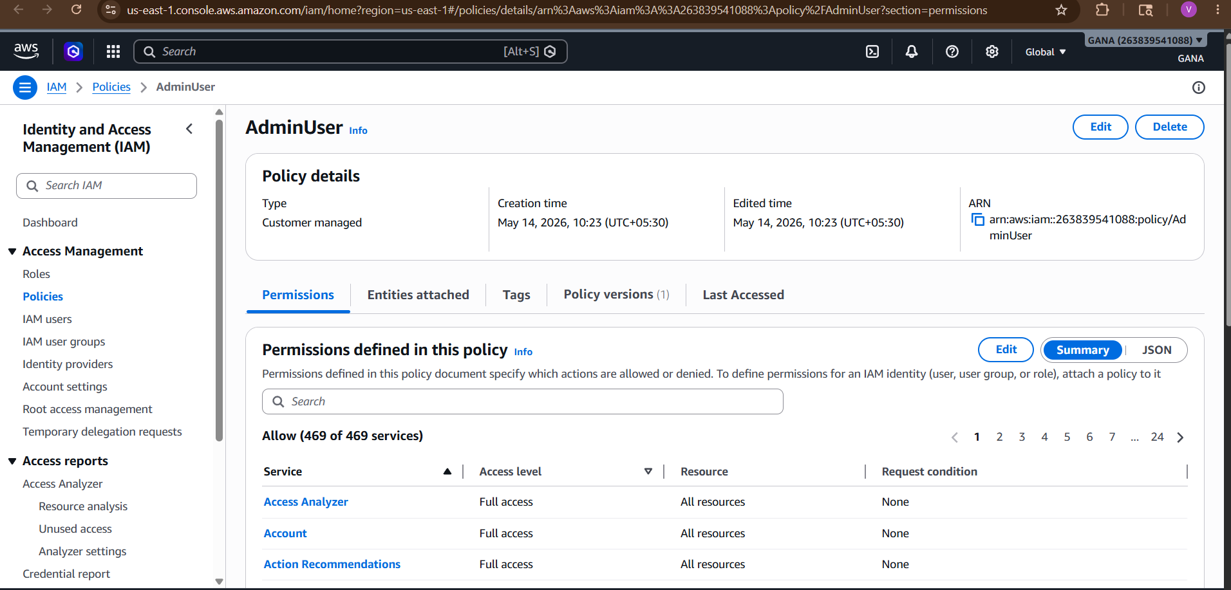

Terraform Destroy Command
To remove created infrastructure:
terraform destroy
Type:
yes
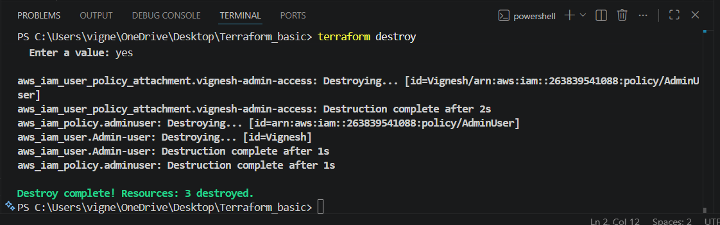

6. Terraform Workflow
## Step-by-Step Process
Step 1
Create Terraform files:
* main.tf
* variables.tf

Step 2
Initialize Terraform:
terraform init

Step 3
Check execution plan:
terraform plan

Step 4
Create infrastructure:
terraform apply

Step 5
Verify resources:
* Check local files
* Check AWS Console

Step 6
Delete infrastructure if needed:
terraform destroy

2). Integrate Terraform in Jenkins using the Terraform plugin.

Jenkins integration with Terraform allows:
- Automated infrastructure deployment
- CI/CD for infrastructure
- Auto provisioning

Architecture
Developer Pushes Code
↓
GitHub Repo
↓
Jenkins Pipeline
↓
Terraform Commands
↓
AWS Infrastructure

STEP 1 — Install Jenkins
Install Java first:
sudo yum install java-17-amazon-corretto -y
Add Jenkins repo:
sudo wget -O /etc/yum.repos.d/jenkins.repo \
https://pkg.jenkins.io/redhat-stable/jenkins.repo
Import key:
sudo rpm --import https://pkg.jenkins.io/redhat-stable/jenkins.io-2023.key
Install Jenkins:
sudo yum install jenkins -y
Start Jenkins:
sudo systemctl enable jenkins
sudo systemctl start jenkins
Check:
sudo systemctl status jenkins

STEP 2 — Install Terraform on Jenkins Server
Download Terraform:
sudo yum install -y yum-utils
sudo yum-config-manager --add-repo \
https://rpm.releases.hashicorp.com/AmazonLinux/hashicorp.repo
Install:
sudo yum -y install terraform
Verify:
terraform -version

STEP 3 — Install Terraform Plugin in Jenkins
Open Jenkins:
http://YOUR_PUBLIC_IP:8080
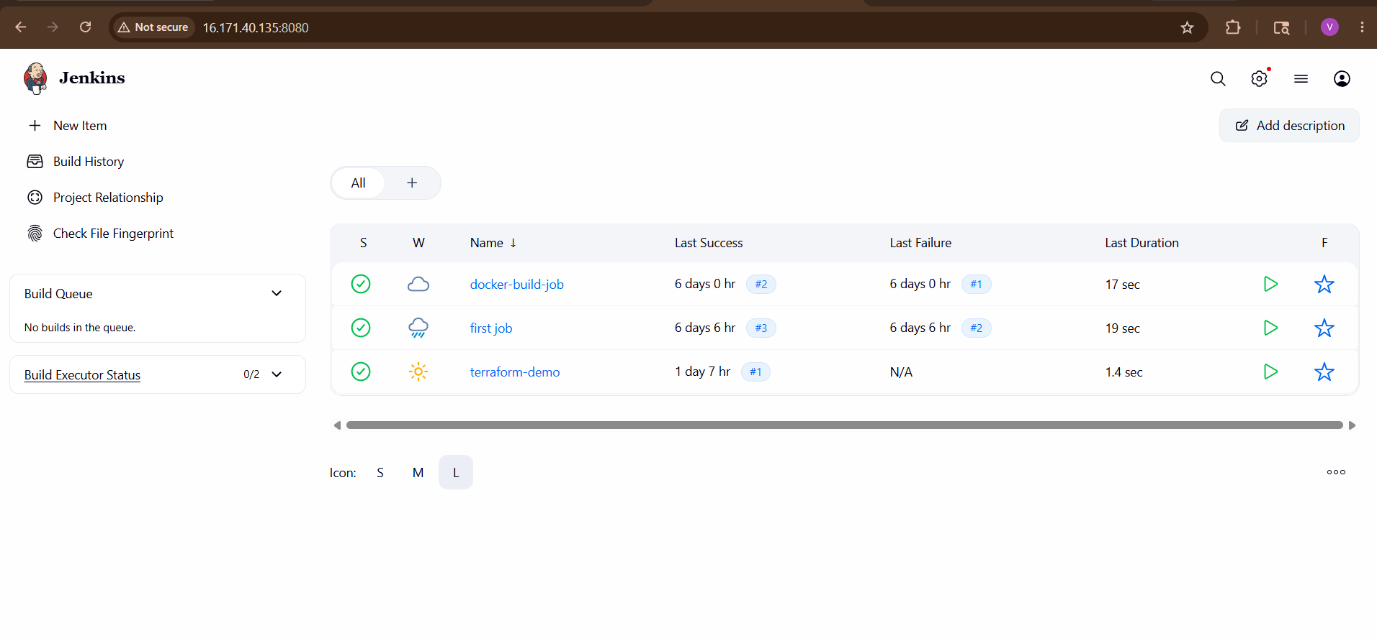Go to:
Manage Jenkins
→ Plugins
→ Available Plugins
Search:
Terraform
Install:
- Terraform Plugin
Restart Jenkins.
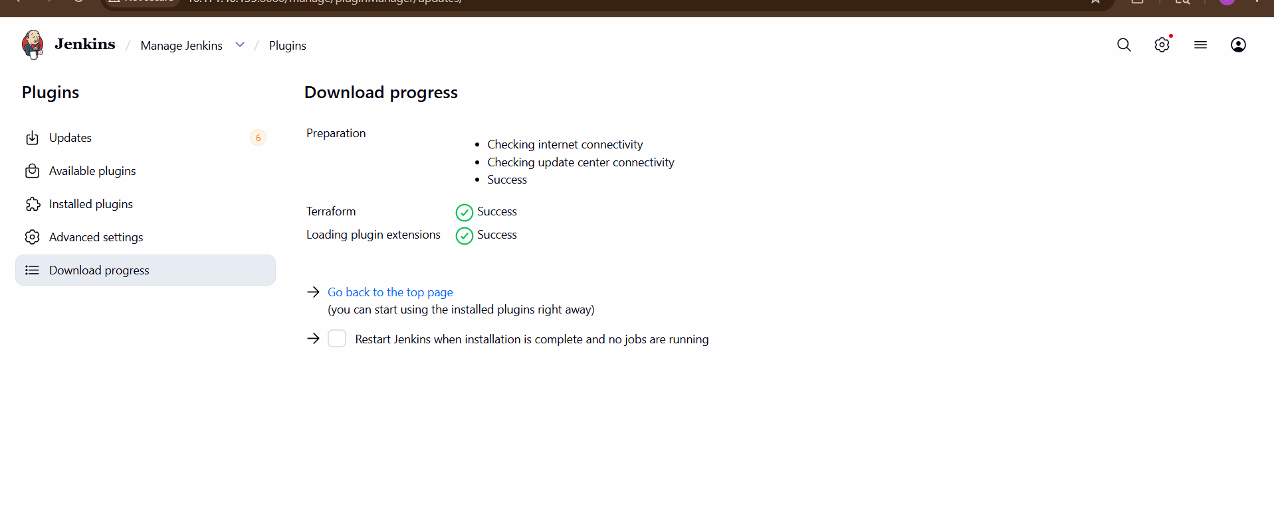

STEP 4 — Configure Terraform Tool
Go to:
Manage Jenkins
→ Tools
Find:
Terraform
Add:
Name: terraform
Install automatically: checked
Version: latest
Save.
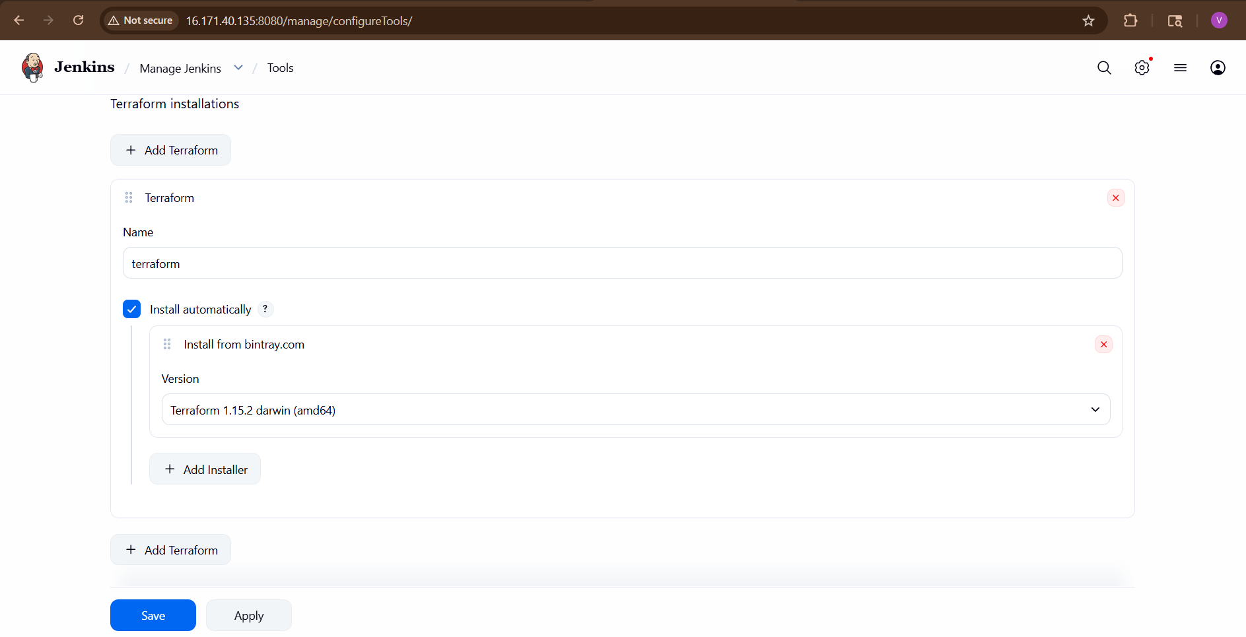

STEP 5 — Install AWS Credentials
On Jenkins server:
aws configure
Enter:
- Access key
- Secret key
- Region
Test:
aws s3 ls

STEP 6 — Create Terraform Project
Create directory:
mkdir terraform-demo
cd terraform-demo
Create main.tf
provider "aws" {
region = "eu-north-1"
}
resource "aws_instance" "demo" {
ami = " ami-0b2ab3a97a77bd35e"
instance_type = "t3.micro"
tags = {
Name = "JenkinsTerraform"
}
}
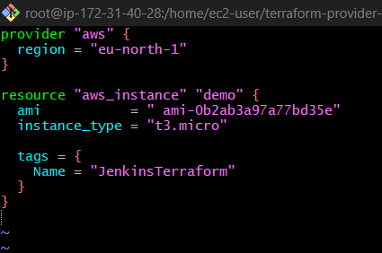

STEP 7 — Push Code to GitHub
Initialize Git:
git init
Add files:
git add .
git commit -m "terraform project"
Push to GitHub.
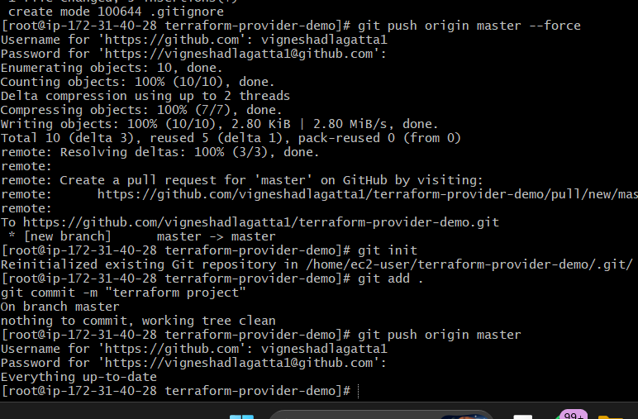

STEP 8 — Create Jenkins Pipeline Job
Go to:
New Item
Select:
Pipeline
Name:
terraform-pipeline
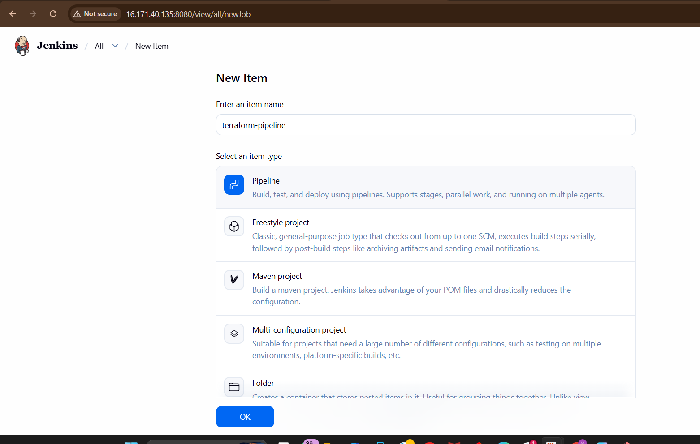

STEP 9 — Configure Pipeline Script
Add this Pipeline:

pipeline {
agent any
tools {
terraform 'terraform'
}
environment {
AWS_DEFAULT_REGION = 'eu-north-1'
}
stages {
stage('Clone Repo') {
steps {
git 'https://github.com/vigneshadlagatta1/terraform-provider-demo.git'
}
}

stage('Terraform Init') {
steps {
withCredentials([[
$class: 'AmazonWebServicesCredentialsBinding',
credentialsId: 'aws-creds'
]]) {
sh 'terraform init'
}
}
}
stage('Terraform Validate') {
steps {
withCredentials([[
$class: 'AmazonWebServicesCredentialsBinding',
credentialsId: 'aws-creds'
]]) {
sh 'terraform validate'
}
}
}
stage('Terraform Plan') {
steps {
withCredentials([[
$class: 'AmazonWebServicesCredentialsBinding',
credentialsId: 'aws-creds'
]]) {
sh 'terraform plan'
}
}
}

stage('Terraform Apply') {
steps {
withCredentials([[
$class: 'AmazonWebServicesCredentialsBinding',
credentialsId: 'aws-creds'
]]) {
sh 'terraform apply -auto-approve'
}
}
}
}
post {
success {
echo 'Terraform Infrastructure Deployment Successful!'
}
failure {
echo 'Terraform Deployment Failed!'
}
}
}
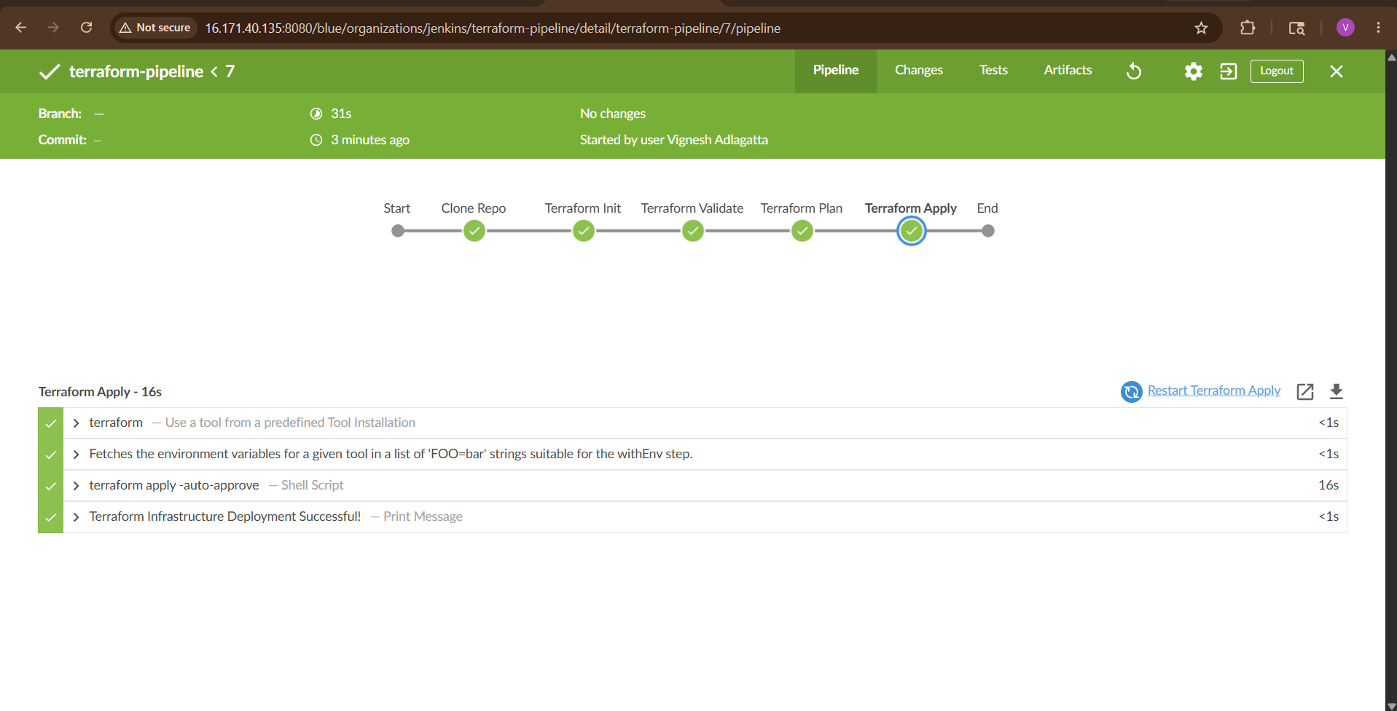

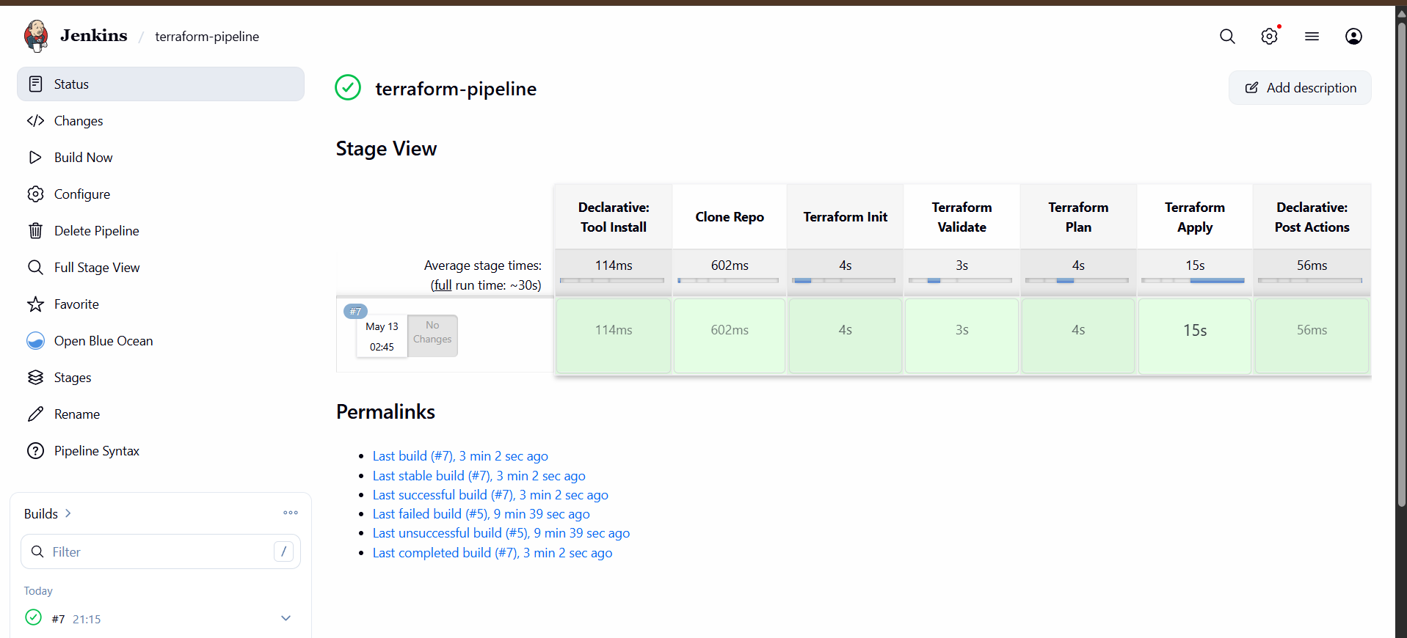

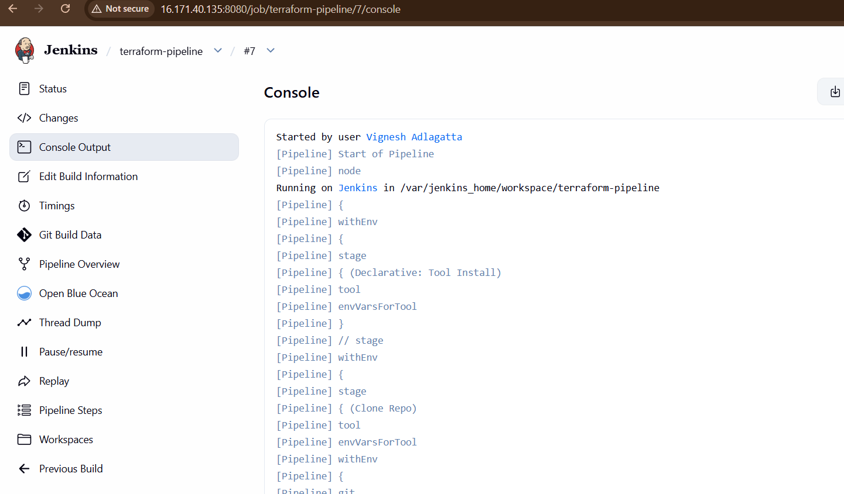

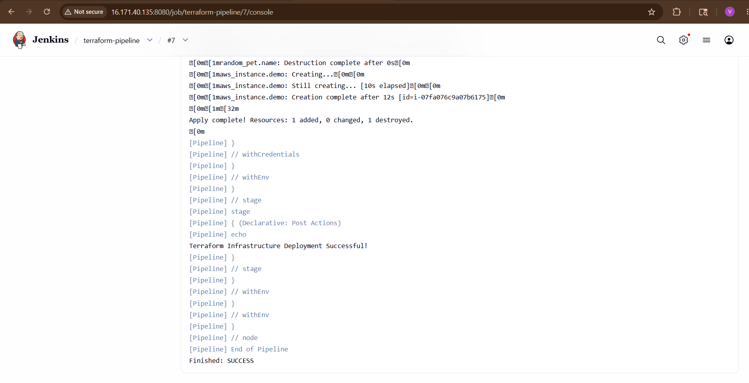
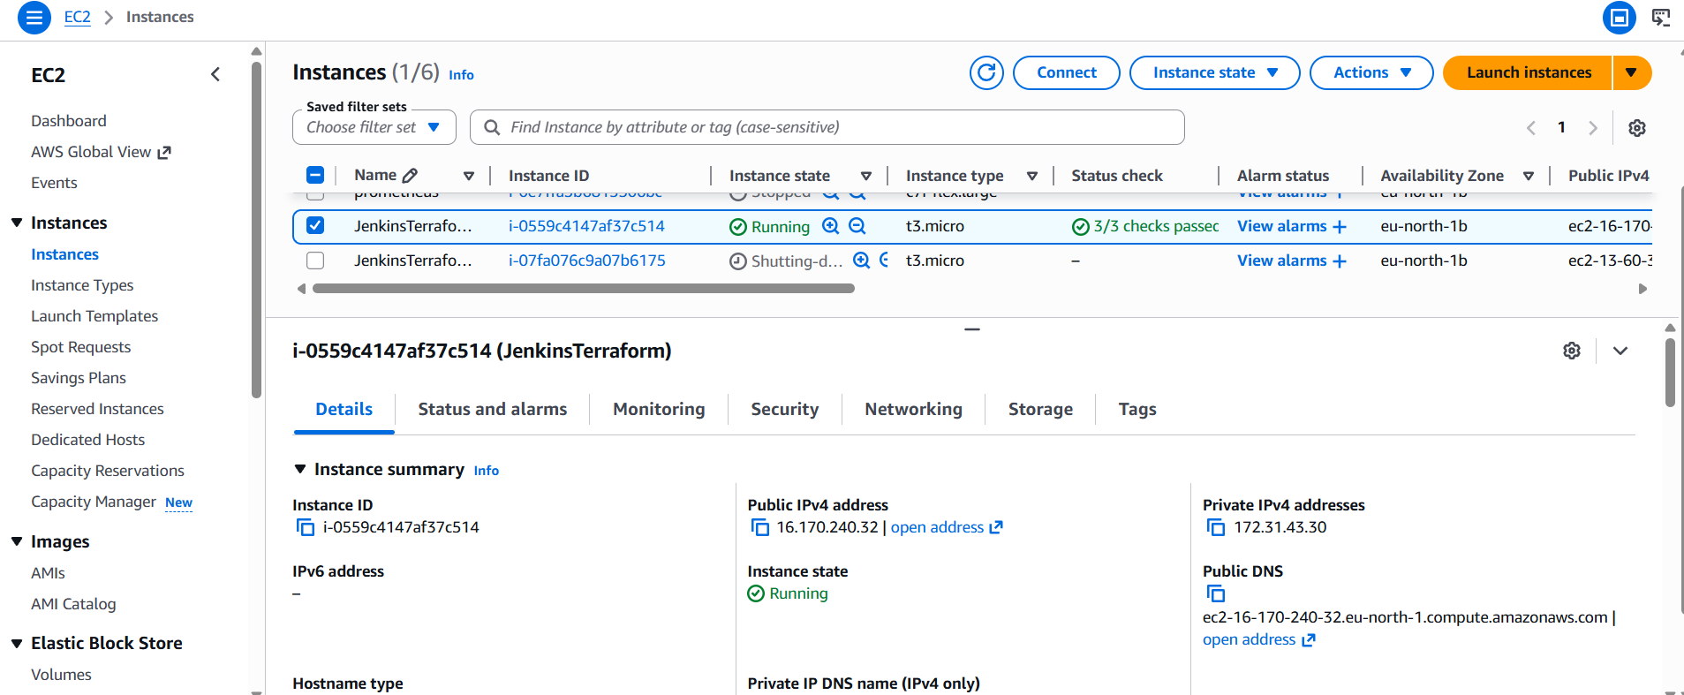

STEP 10 — Build Pipeline
Click:
Build Now
Pipeline automatically:
- Clones repo
- Initializes Terraform
- Validates code
- Creates execution plan
Deploys infrastructure

3). Create a CI/CD pipeline for a Nodejs Application: https://github.com/betawins/Trading-UI.git
Trading-UI GitHub Repository
Pipeline Flow:
GitHub → Jenkins → npm install → Build → Docker Build → Docker Run
Prerequisites
Install:
- Jenkins
- Docker
- Git
- Node.js
- Java (for Jenkins)

STEP 1 — Launch Jenkins Server
Create EC2 Ubuntu Server.
Recommended:
- Ubuntu 22.04
- t2.medium
Open Ports:
- 22
- 8080
- 3000

STEP 2 — Install Jenkins
Update Server
sudo apt update

Install Java
sudo apt install openjdk-17-jdk -y
Check:
java -version

Install Jenkins
curl -fsSL https://pkg.jenkins.io/debian-stable/jenkins.io-2023.key | sudo tee \
/usr/share/keyrings/jenkins-keyring.asc > /dev/null
echo deb [signed-by=/usr/share/keyrings/jenkins-keyring.asc] \
https://pkg.jenkins.io/debian-stable binary/ | sudo tee \
/etc/apt/sources.list.d/jenkins.list > /dev/null
sudo apt update
sudo apt install jenkins -y

Start Jenkins
sudo systemctl enable jenkins
sudo systemctl start jenkins
Check:
sudo systemctl status jenkins

STEP 3 — Install Docker
sudo apt install docker.io -y
Start Docker:
sudo systemctl enable docker
sudo systemctl start docker
Check:
docker --version

STEP 4 — Give Jenkins Access to Docker
Very Important.
sudo usermod -aG docker jenkins
sudo usermod -aG docker ubuntu
Restart Jenkins:
sudo systemctl restart jenkins

STEP 5 — Install Node.js
Install Node.js 18 on Amazon Linux
STEP 1 — Update Packages
sudo yum update -y
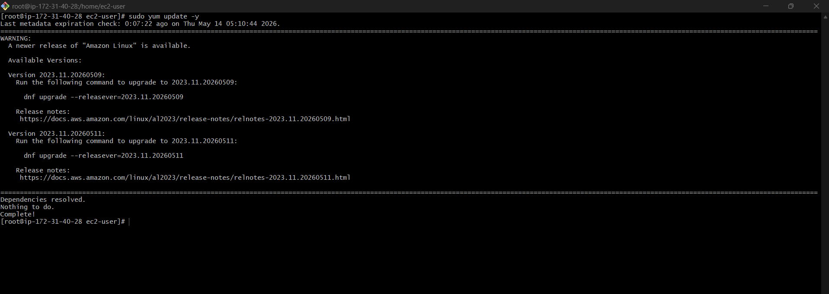

STEP 2 — Install Node.js 18
For Amazon Linux 2
curl -fsSL https://rpm.nodesource.com/setup_18.x | sudo bash -
sudo yum install -y nodejs
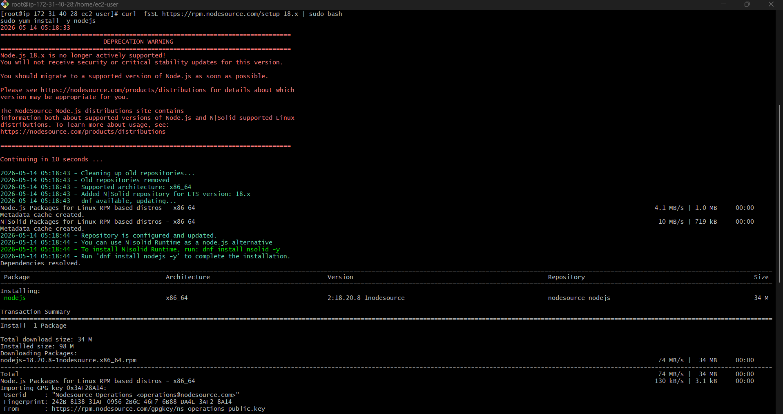
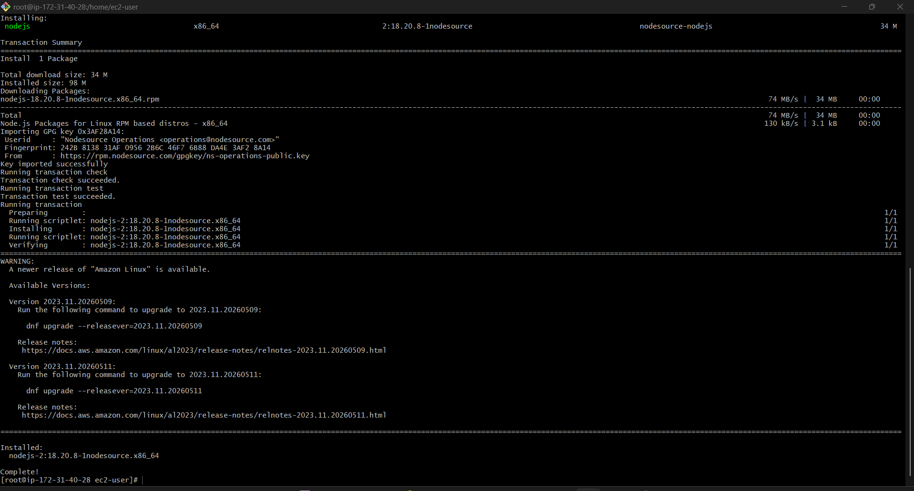

For Amazon Linux 2023
curl -fsSL https://rpm.nodesource.com/setup_18.x | sudo bash -
sudo dnf install -y nodejs
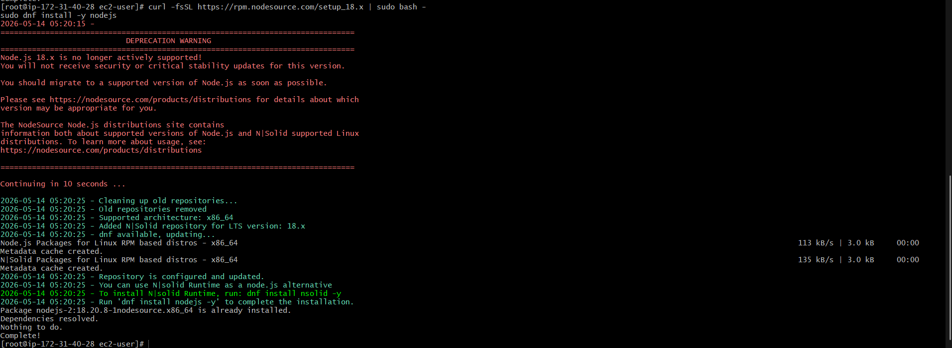

STEP 3 — Verify Installation
node -v
Expected:
v18.x.x
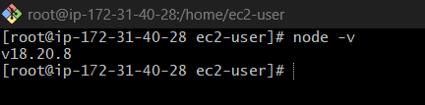
Check npm:
npm -v
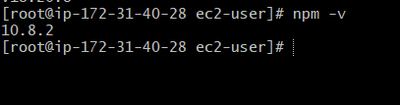

Example Output
[root@ip-172-31-xx-xx ~]# node -v
v18.20.8
[root@ip-172-31-xx-xx ~]# npm -v
10.8.2

STEP 6 — Open Jenkins
Browser:
http://YOUR_PUBLIC_IP:8080
Get password:
sudo cat /var/lib/jenkins/secrets/initialAdminPassword
Install:
- Suggested Plugins
Create:
- Admin User

STEP 7 — Install Required Jenkins Plugins
Go to:
Manage Jenkins → Plugins
Install:
- Docker Pipeline
- NodeJS
- Git
- Pipeline
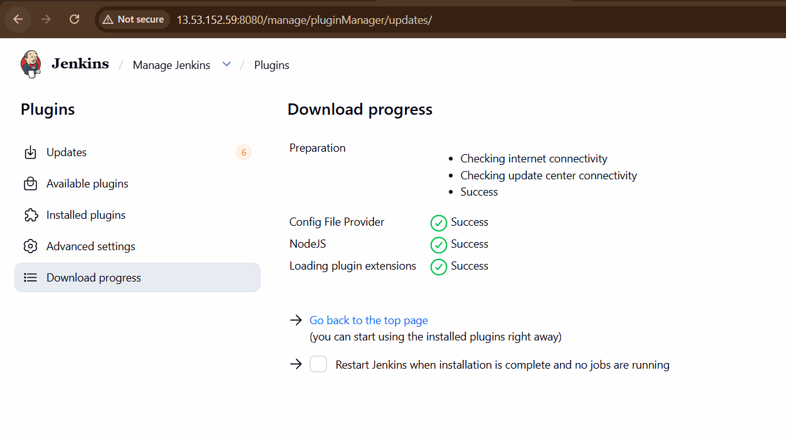
Restart Jenkins.

STEP 8 — Configure NodeJS in Jenkins
Go to:
Manage Jenkins → Tools
Add NodeJS:
Name: node18
Check:
- Install Automatically
Version:
- NodeJS 18
Save.
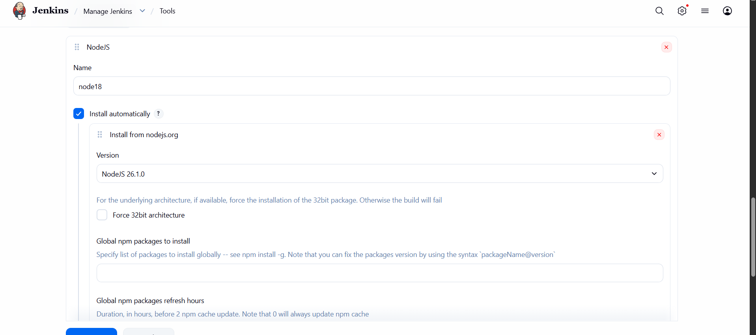

STEP 9 — Create Pipeline Job
Go to:
New Item
Choose:
- Pipeline
Name:
Trading-UI-CICD
Click OK.

STEP 10 — Create Dockerfile
Inside project:
git clone https://github.com/betawins/Trading-UI.git
cd Trading-UI
Create Dockerfile:
vi Dockerfile
Paste:
FROM node:18
WORKDIR /app
COPY package*.json ./
RUN npm install
COPY . .
ENV NODE_OPTIONS=--openssl-legacy-provider
RUN npm run build
RUN npm install -g serve
EXPOSE 3000
CMD ["serve", "-s", "build", "-l", "3000"]
Save.
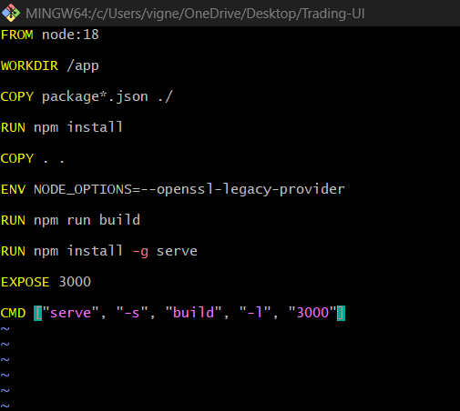

STEP 11 — Push Dockerfile to GitHub
git add .
git commit -m "Added Dockerfile"
git push

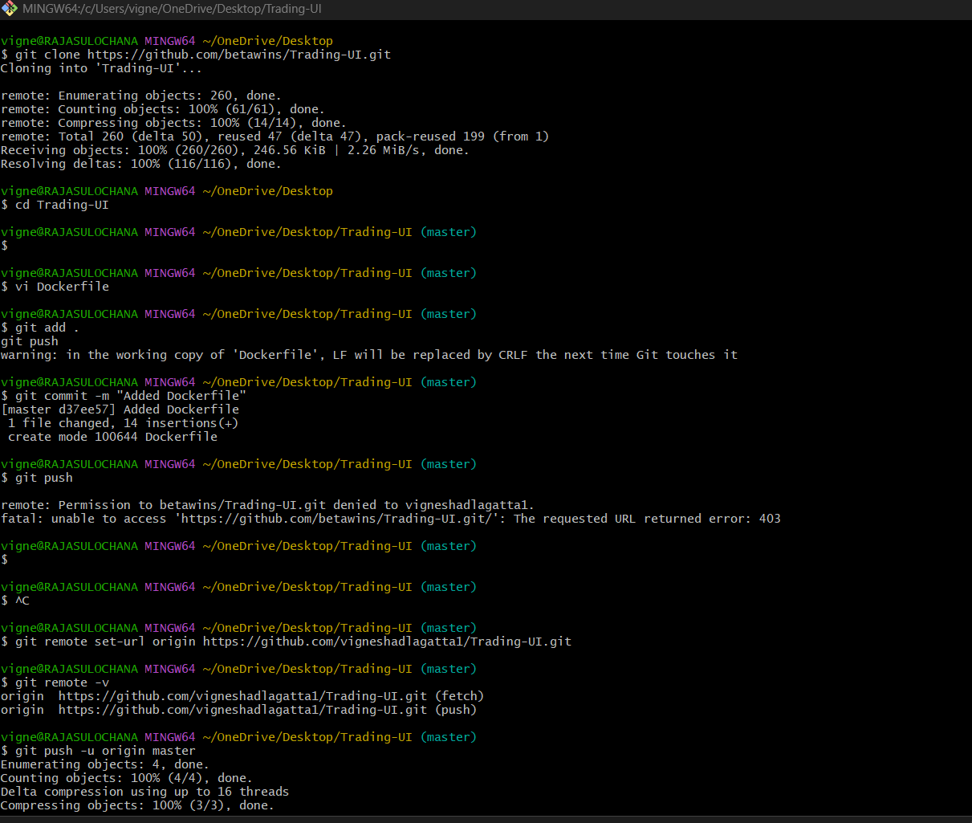
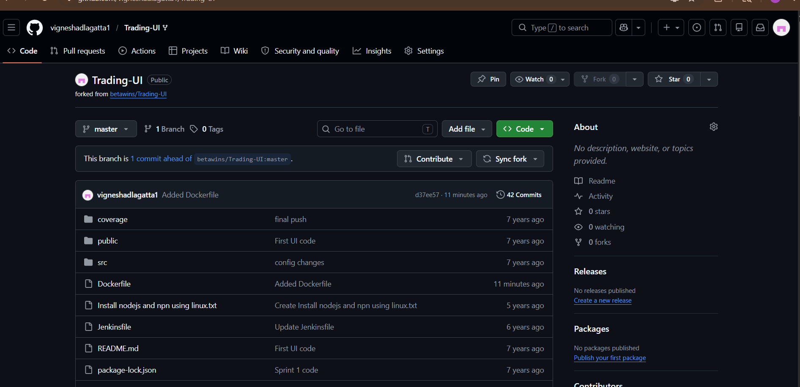

STEP 12 — Create Jenkins Pipeline
Go to Jenkins Job:
Pipeline → Definition → Pipeline Script
Paste:
pipeline {
agent any
tools {
nodejs 'node18'
}
environment {
APP_NAME = "trading-ui"
CONTAINER_NAME = "trading-ui-container"
}
stages {
stage('Clone Repository') {
steps {
git 'https://github.com/vigneshadlagatta1/Trading-UI.git'
}
}
stage('Check Node Version') {
steps {
sh 'node -v'
sh 'npm -v'
}
}
stage('Install Dependencies') {
steps {
sh 'npm install'
}
}

stage('Build Application') {
steps {
sh 'npm run build || true'
}
}
stage('Docker Build') {
steps {
sh 'docker build -t $APP_NAME .'
}
}
stage('Remove Old Container') {
steps {
sh 'docker rm -f $CONTAINER_NAME || true'
}
}
stage('Run Docker Container') {
steps {
sh '''
docker run -d \
--name $CONTAINER_NAME \
-p 3000:3000 \
$APP_NAME
'''
}
}
stage('Verify Container') {
steps {
sh 'docker ps'
}
}
}

post {
success {
echo 'Application Deployed Successfully'
}
failure {
echo 'Pipeline Failed'
}
always {
echo 'Pipeline Execution Completed'
}
}
}
Save.

STEP 13 — Build Pipeline
Click:
Build Now

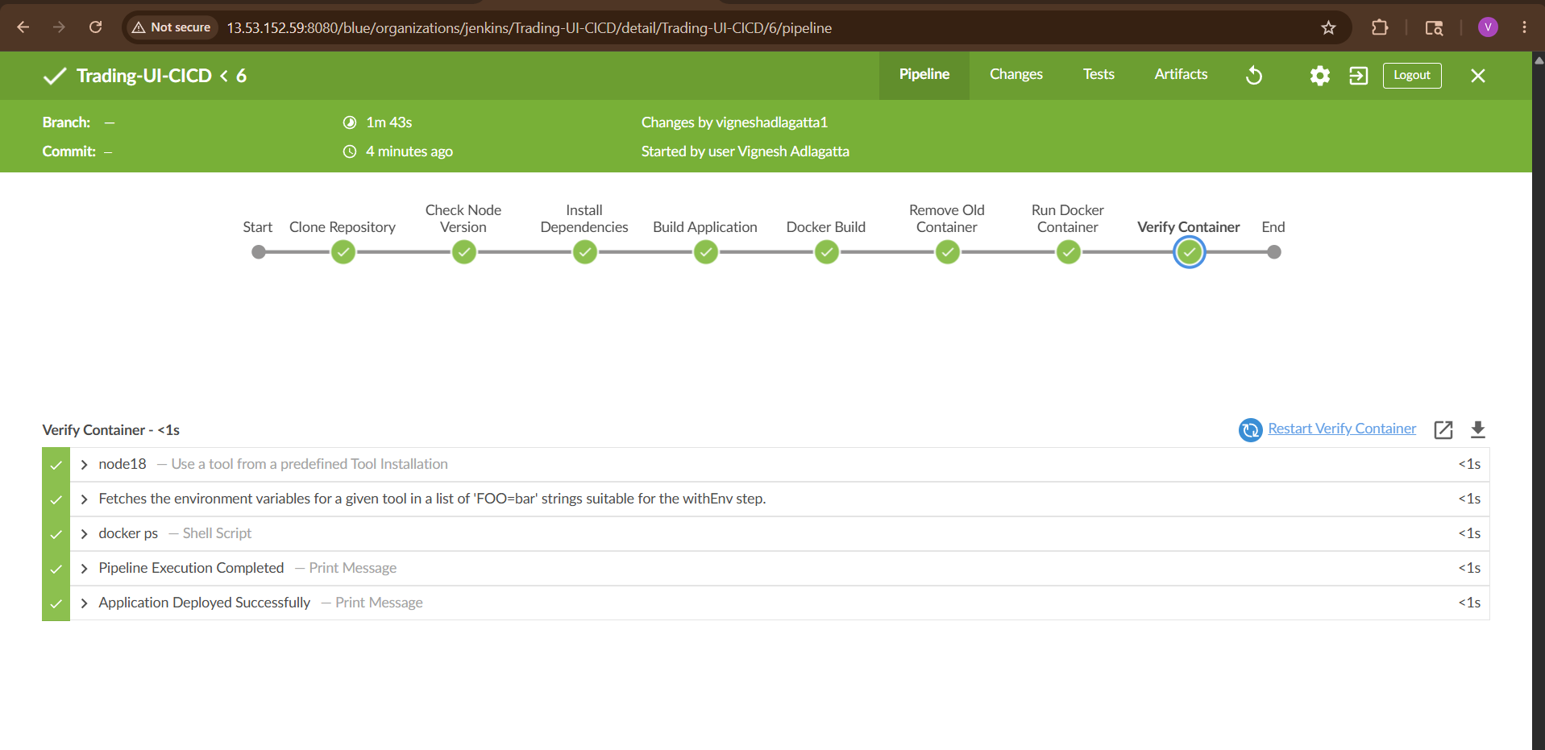
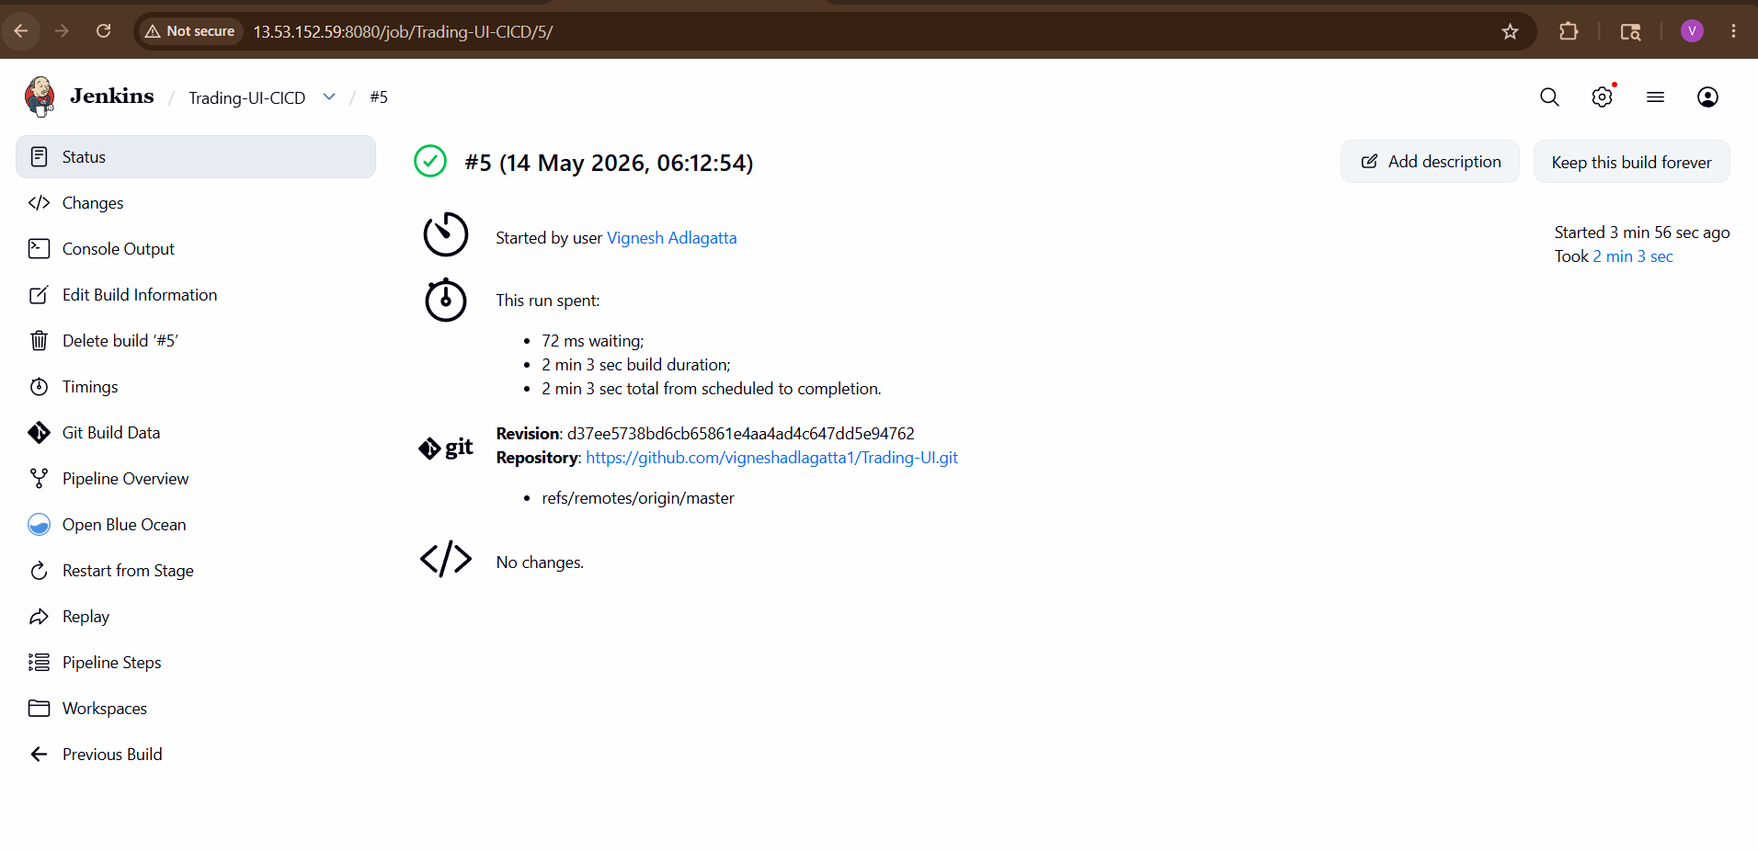
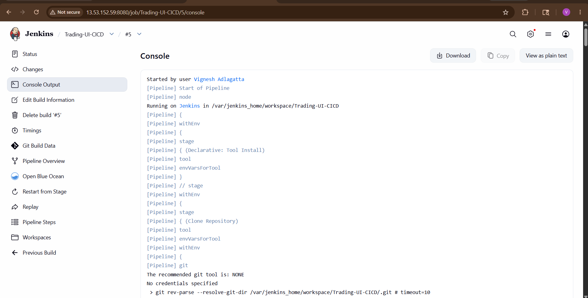
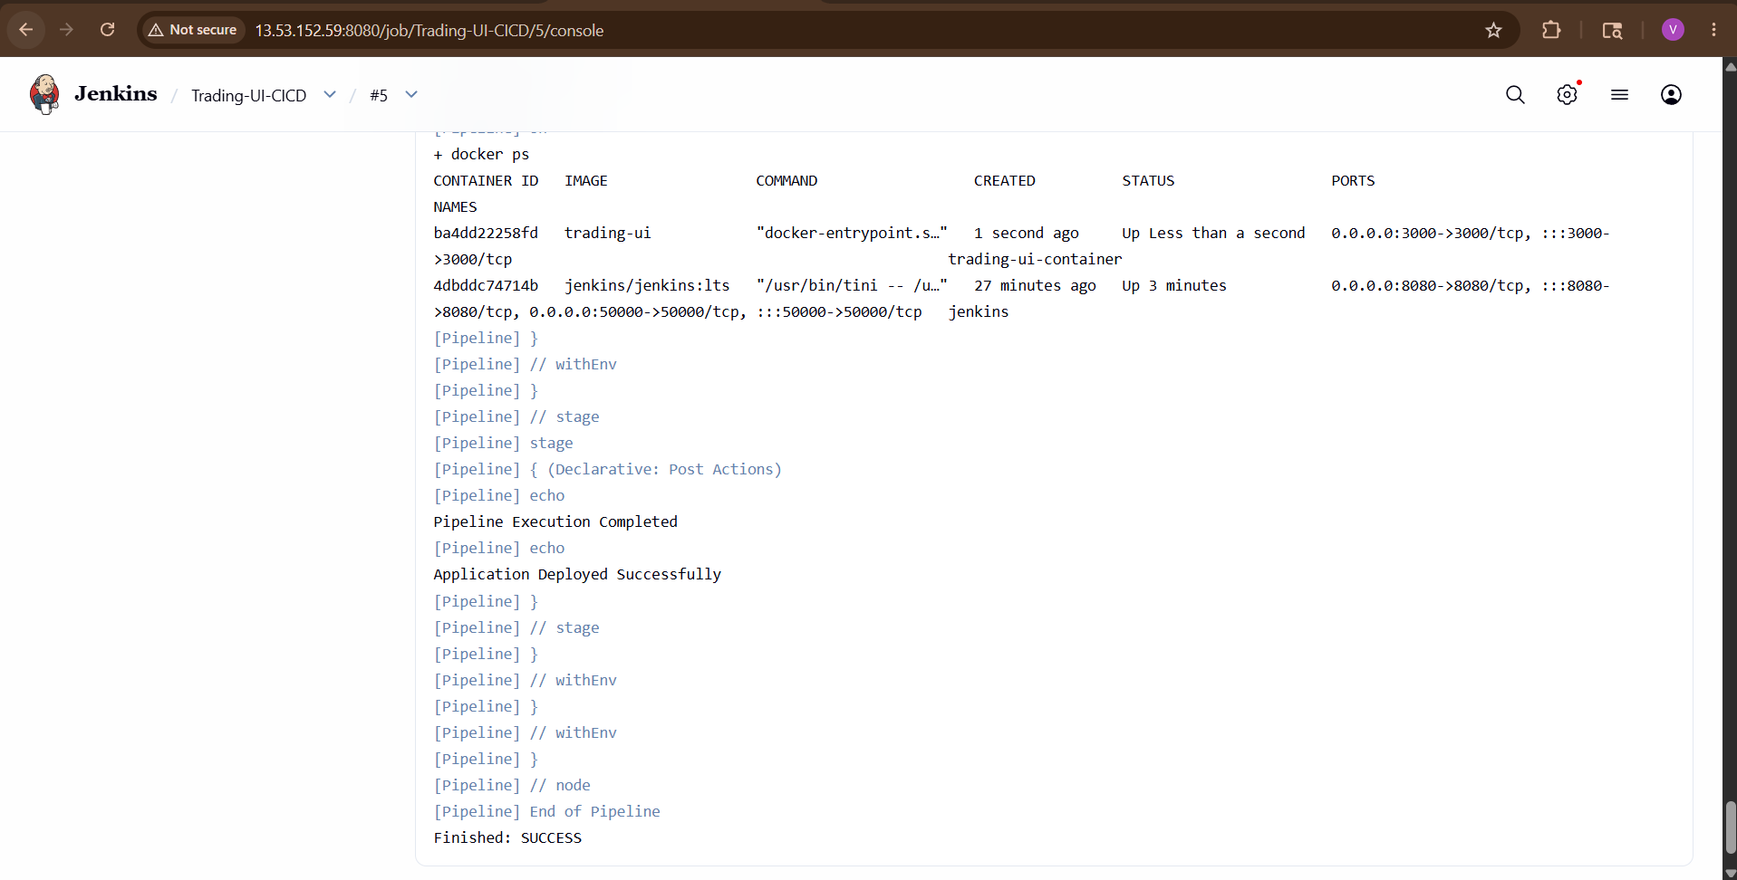
STEP 14 — Verify Running Container
Server:
docker ps -a
Expected:
trading-ui-container
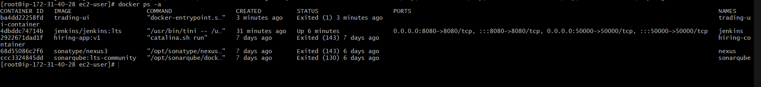

STEP 15 — Access Application
Browser:
http://PUBLIC_IP:3000
http://13.53.152.59:3000/#/

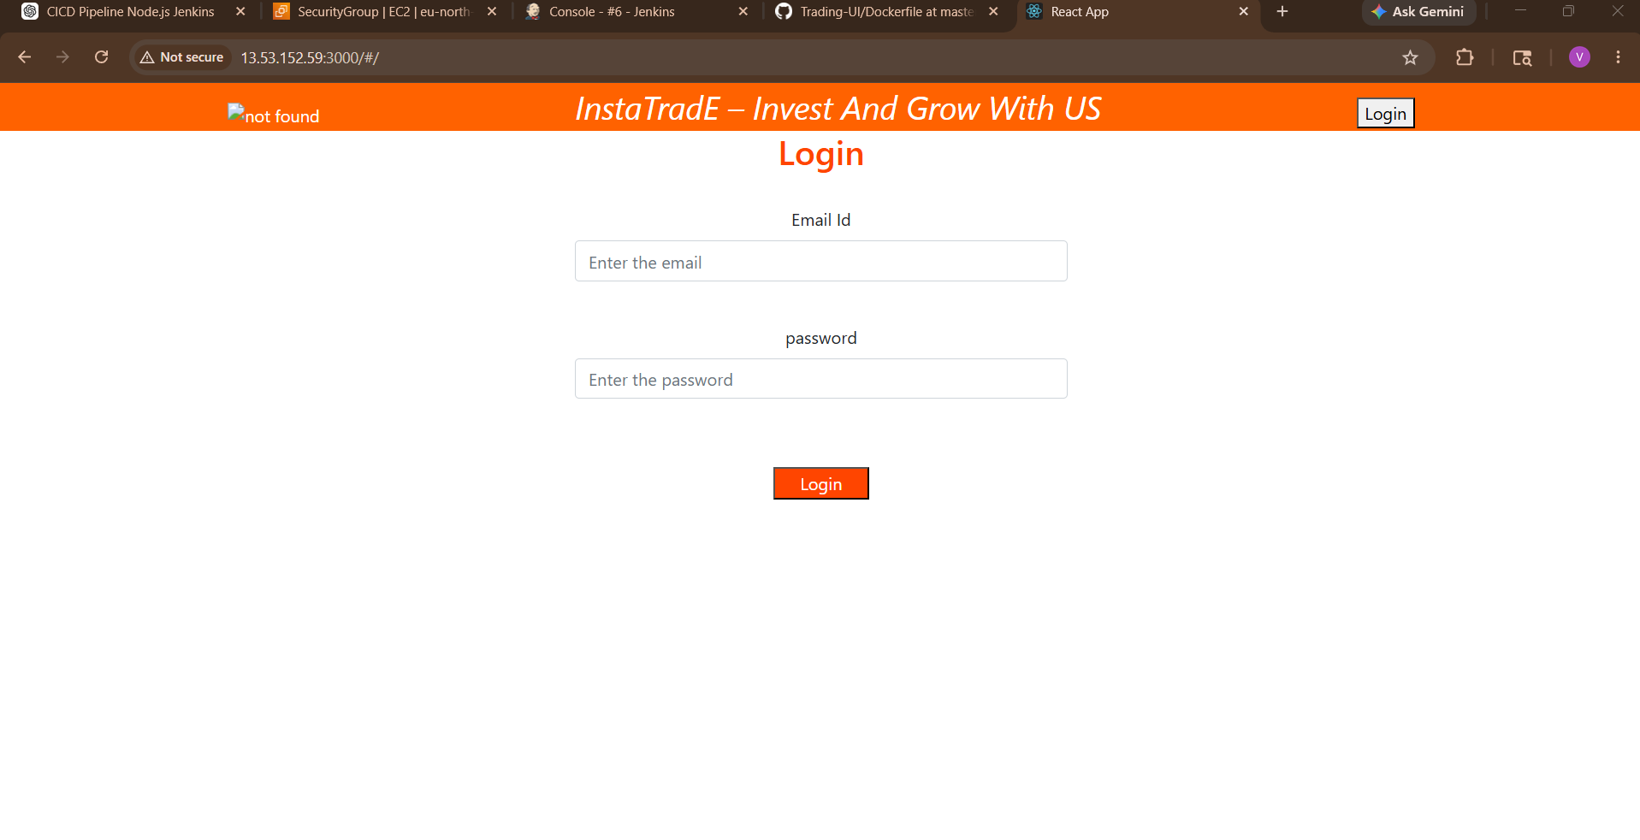

4). Explain 10 Maven commands

Maven is a:
- Build automation tool
- Dependency management tool
- Project management tool
Used mainly for:
- Java
- Spring Boot
- Microservices projects

Maven Lifecycle Flow
validate
↓
compile
↓
test
↓
package
↓
verify
↓
install
↓
deploy

1. mvn validate
Purpose
Checks:
- Project structure
- pom.xml validity
without compiling code.

Command
mvn validate

Real-Time Use
Before starting build:
- Verify project correctness

Example
BUILD SUCCESS

2. mvn compile
Purpose
Compiles Java source code.
Converts:
.java → .class

Command
mvn compile

Output Location
target/classes

Real-Time Example
Developer checks:
- Compilation errors
- Syntax issues
before packaging.

3. mvn test
Purpose
Runs unit test cases.
Usually:
- JUnit
- TestNG

Command
mvn test

Real-Time Example
CI pipeline validates:
- Application logic
- Test cases
before deployment.

4. mvn package
Purpose
Creates deployable file:
- JAR
- WAR

Command
mvn package

Output
target/app.jar
or
target/app.war

Real-Time Example
Used before:
- Docker build
- Kubernetes deployment

5. mvn clean
Purpose
Deletes old build files.
Removes:
target/
folder.

Command
mvn clean

Real-Time Example
Avoids:
- Old cache issues
- Duplicate class issues

6. mvn clean install
Purpose
Most commonly used Maven command.
Performs:
clean → compile → test → package → install

Command
mvn clean install

What is "install"?
Stores artifact in local Maven repository:
~/.m2/repository

Real-Time Example
Developers use this daily.
CI/CD pipelines also use it heavily.

7. mvn deploy
Purpose
Uploads artifact to:
- Nexus
- Artifactory
- Remote Maven repository

Command
mvn deploy

Real-Time Example
Enterprise pipelines:
Build → Test → Package → Deploy to Nexus

8. mvn dependency:tree
Purpose
Displays project dependencies tree.

Command
mvn dependency:tree

Example Output
spring-core
└── commons-logging

Real-Time Example
Useful for:
- Dependency conflicts
- Version issues
9. mvn spring-boot:run
Purpose
Runs Spring Boot application directly.
No need:
- JAR execution
- Tomcat deployment
Command
mvn spring-boot:run
Real-Time Example
Developers run applications locally.
10. mvn site
Purpose
Generates project documentation website.
Command
mvn site
Output
target/site

Real-Time Example
Creates:
- Project reports
- Test reports
- Documentation

